‘Roxbury Strong’ tells a neighborhood’s story
1COMMENTPRINT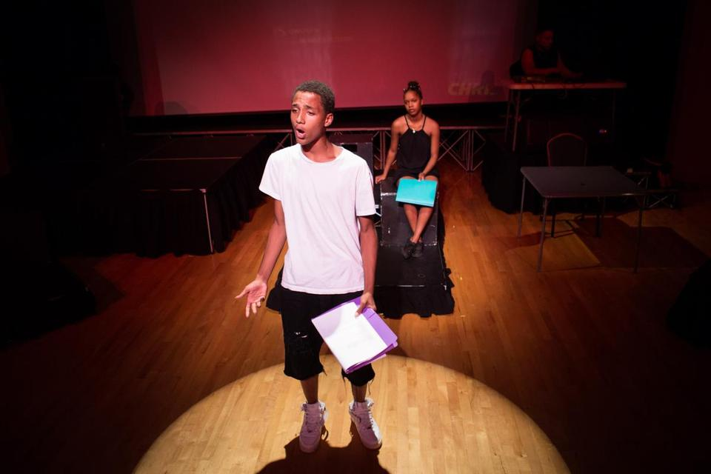
KAYANA SZYMCZAK FOR THE BOSTON GLOBE
Jayden Pontes rehearses a scene from “Roxbury Strong” as Shay Jean looks on.
By Sophie Haigney GLOBE CORRESPONDENT AUGUST 17, 2016
“What makes up a so-called neighborhood?” actor Jayden Pontes asks — or rather, raps, at the opening of Ron Jones’s new play, “Roxbury Strong: A Story of Emergence.” Other actors step forward to offer possibilities: bricks and mortar, roads, storefronts, schools, churches, playgrounds, and parks. But no, says Shay Jean, speaking deliberately: “When it’s all said and done, a neighborhood is its story.”
That opening claim is central to plot of “Roxbury Strong” — and to its broader intentions. The play will be performed by Boston-area high school students — mostly from Boston Arts Academy — Thursday and Saturday at Hibernian Hall. It revolves around first-person stories from Roxbury residents and aims to reframe conventional narratives about their neighborhood.
“When I came to [Boston College], people explicitly told me, ‘Do not go to Roxbury,’ ” says Jones, an actor, playwright, and director of the nonprofit Dialogues on Diversity. Jones is originally from Washington, D.C., but he has lived mostly in Boston since 1984. He said that characterizations of Roxbury in the early 1980s involved guns, drugs, and violence. Today, that narrative has shifted somewhat, to include gentrification, rising prices, and displacement.
It’s not that those factors didn’t and don’t play large roles Roxbury’s story, Jones said. It’s that the story’s more complicated.

“I think there’s a lot of affirmation in owning your narrative, and not letting an environmental narrative become yours,” Jones says. “That’s not just in Roxbury. That’s if you’re in the most violent part of Chicago, or if you’re in the coal mines of Appalachia.”
The play was commissioned by the community-based nonprofit Madison Park Development Corp., in celebration of its 50th anniversary. The organization’s artistic director, Dillon Bustin, reached out to Jones, who had performed his one-man show “The Movement” at Hibernian Hall last summer.
MPDC traces its history to 1966 — a pivotal moment in the context of Boston’s urban renewal and the national civil rights movement. Bustin said the organization wanted to do something to commemorate this history. He thought of Jones’s work.
“I knew he was very experienced at working with young people, with devising stage work out of oral history interviews, with using visual images, which was all the sort of thing I had in mind,” Bustin says.
And so Jones began the process of writing “Roxbury Strong” last April. He spent hours in Northeastern University’s archives. He estimated that he conducted more than 70 hours of interviews with nearly 50 people who had ties to the neighborhood. He interviewed people from all walks of life, from Boston Police Superintendent-in-Chief William Gross to Tariq Russell, a lifelong resident who has been shot nine times in multiple incidents.
The interviews, some of which Jones provided to the Globe in video form, touch on a broad range of topics. In one, John Jackson, administrative coordinator at the Tobin Community Center and former basketball coach at Roxbury Community College, talked about the joy of winning the men’s Division III national championship in 2000, and his disappointment that the media and city ignored it. “There’s only six national [basketball] championships, in the whole USA,” Jackson said. “We had one of them and we had nothing, no fanfare.”
In another, director and curator of the Museum of the National Center of Afro-American Artists Edmund Barry Gaither (who has worked in Roxbury since 1969) discussed how gentrification could become a positive force in the neighborhood, if done well.
Gross discussed the mishandling of the Charles Stuart case in 1989. Stuart, who was white, murdered his pregnant wife and then shot himself to make it appear they had been the victims of a robbery, telling the police their assailant was a black male. The police investigation in Mission Hill and surrounding neighborhoods involved the stopping and searching of black men without warning — and the eventual arrest of William “Willie” Bennett. (Bennett remained behind bars until Stuart was implicated in the murder by his own brother and killed himself.)
“There was a perception that because there was the homicide of a white female, the black community as a whole was being punished,” said Gross, who was a police officer at the time.
Jamila Capitman, 29, is an artist, entrepreneur, and educator who has lived in Roxbury since 2004. In her interview with Jones, she discussed the “spiritual” response to the persistent gun violence in the neighborhood.
“This is a sacred space, going back to the fact that there are so many lives lost within the space that we call Roxbury,” Capitman said. “People celebrate their dead here. You drive through the streets and you see these memorials with teddy bears and flowers and candles. That’s not garbage. That’s not a mess. That’s not trash. That’s not graffiti. That’s a spiritual thing.”
In a follow-up interview with the Globe, Capitman says that one of the emotionally difficult things about gentrification is the lack of awareness — or apparent interest — in this aspect of the neighborhood’s history. “When you have a gentrifier move in who doesn’t have understanding, then you lose a piece of that history,” she says. “You wonder, is my trauma, is my pain, worth anything to the people who are buying the property?”
Weaving these different threads together was a challenge for Jones. “The hardest thing about this process was trying to distill those interviews into a single script,” he says.
His solution was to frame “Roxbury Strong” around the story of a boy, played by the 16-year-old Pontes, and an older woman, played by Jean, who’s 17. The boy is struggling to find a job, and he complains to her about gentrification. The woman asks him whether he knows anything about the neighborhood’s history — and hires him to go and learn about it.
So he talks to people in the neighborhood, and a chronological picture of Roxbury emerges. The other characters are people whom Jones interviewed, and most of the dialogue is drawn directly from their conversations, with some changes. With the exceptions of Jean and Pontes, each actor plays multiple roles, sometimes vastly different ones (Fredrick Woodard plays both Gaither and Russell, for instance). In the background, video and photo projections show Roxbury through the years. Music from local songwriter and rapper Mike Boston — some of which was written in collaboration with the actors — is featured in the play.
Roughly the first three quarters of “Roxbury Strong” deal with the past, but the end addresses the future: with further gentrification, with persistent inequalities, and how these might be corrected.
The future is an important piece of Roxbury’s story, because that story isn’t over. “No one really owns a neighborhood, because a neighborhood is constantly in flux,” Jones says to Gross in a video of their conversation. “What matters most about a neighborhood is what you do when you’re in it, what is going to be the story that we’re going to be telling 100 years from now about this place, and this time, and these people? And my hope would be it’s that people here are resilient.”

